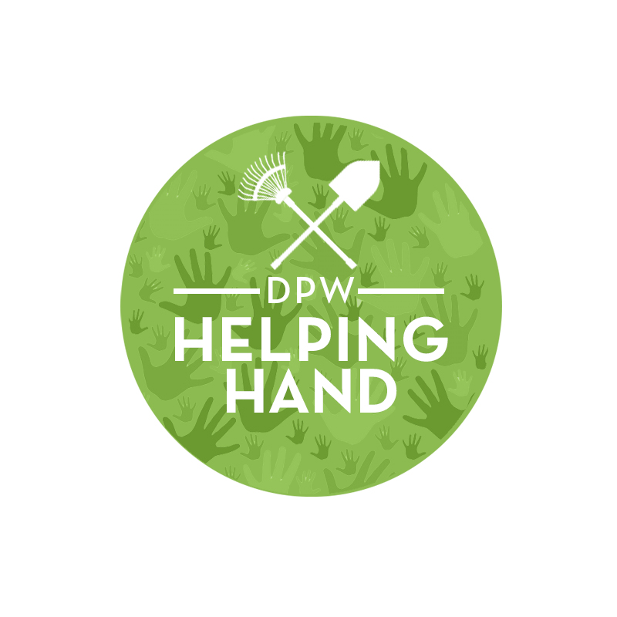
DPW HELPING HAND NEIGHBORHOOD CLEAN-UP
APPLICATION FORM – APPROVAL # ____________
Date of Event:____________________

Event Location:_________________________________________________________________________

Sponsor/Coordinator Name/Contact Person: __________________________________________
Address: ______________________________________________________________________________
City__________________________ State______________________ Zip code: ___________________
Telephone # Day: ________________Evening:________________ Fax: __________________
Alternate Contact Person: ______________________________________________________
Telephone # Day: ______________Evening :____________________ Fax:______________
Services/Materials Needed (Please indicate number needed) ___________ tool kit(s) _______trash bags

***ABSOLUTELY NO BULK COLLECTION***

Collection point (Limit 3 locations) BAGGED trash only
- ________ ______________________________________________________________
- _______________________________________________________________________
- _______________________________________________________________________

FOR TOOL KIT (S) DELIVERY ONLY:
Deliver tool kit(s) to: _______________________________________________________
Address: _________________________________________________________________
Telephone # Day: ___________________ Evening:_____________
Delivery Preference: Day/Time___________ (No Evening Deliveries)

FOR DPW USE ONLY
Delivered by: __________________ to: _______________ Date: _________
Returned to: ___________________ to: _______________ Date: _________
Check Received ___/___ Check Returned ___/___

Complete tool kit(s) () yes () no

If no, what was damaged or not returned? _________________________________________________________________________________
_________________________________________________________________________________
Designated tool kit(s) person’s signature: _______________________________________________________
Waiver: I have read and fully understand the DPW Helping Hand Program policy. I understand that all participants in my organization are volunteers and I am responsible for each participant’s behavior. In consideration of my acceptance as a participant in the Helping Hand Program, I agree to release the Department of Public Works and all sponsors of any and all claims which may arise as a result of any expenses, personal injuries, loss or damage incurred by my organization group. I understand that an adult will accompany any volunteer under the age of 21. I further agree that any items in the tool kit(s) if lost or damaged will be paid for or replaced by articles of equal value.

Signature of Coordinator________________________________ Date:_____________________
Solid Waste Management Administration-Solid Waste Education & Enforcement Program
Telephone # (202) 645-7190 Facsimile # (202) 645-8518

DPW HELPING HAND NEIGHBORHOOD CLEAN-UP
APPLICATION INSTRUCTIONS AND GUIDELINES

Thank you for coordinating a Helping Hand Neighborhood Clean-Up. This program is used in collaboration between District Government and Neighboring Communities. These instructions provide general guidelines about the Helping Hand Program, and information required to complete the application process.

Submit Helping Hand Application Forms:
Application forms must be received at least (2) weeks in advance of a scheduled clean-up event NO EXCEPTIONS . The application may be sent by mail to 250 E Street, SW Suite 430 Washington, DC 20024 or via fax (202) 645-8518. The Department of Public Works (DPW) will only provide services for an event that has been confirmed by the SWEEP office. SWEEP inspectors will deliver tools, help organize the clean up and provide technical support.

Designate Contact Person:
Application forms must include the name, address and phone number(s) of the designated Contact Person. The contact person is responsible for (a) overall coordination of clean-up event and communication with DPW Helping Hands program staff:
(b) receiving and retaining tools loaned by the Department of Public Works, as well as securing the $20.00 deposit for each tool kit(s) and (c) ensuring that all trash generated at the event is placed at no more than three locations for collection by the Department of Public Works.

Identify Locations for DPW Collection:
The bags of trash collected during the clean up must be placed at no more than three (3) pre-designated pick-up points. All scheduled clean ups should be completed by 1:00pm the day of clean-up to ensure trash pick up for that day. Any scheduled clean ups concluding after 2:00pm will in most cases be picked up the next day. (Sunday) There will be no trash pick-up for unscheduled clean-ups Saturday or Sunday. Uncollected trash will be picked up between Monday and Wednesday.
NO EXCEPTIONS!!!

Tool Kits:
The Department of Public Works will loan your group tools to assist your clean-up efforts. Each tool kit contains: 5 rakes, 5 brooms, 2 shovels and 20 trash bags (NO GLOVES OR TRASH PICKERS). Tool kits will not be broken up. A $20.00 refundable deposit is required per tool kit loaned under the Helping Hand Program. Checks or money orders should be made payable to the DC Treasurer. Refunds will be made after all tools are returned in good condition. Lost equipment must be paid for or replaced by articles of equal value.

What is collected by the Department of Public Works?
1. Only trash in bags that have been provided by DPW or bundled debris at the designated point of
collection.
2. Wood and tree limbs must be cut into four foot lengths, no wider than 6” in diameter weighing no more than 60 lbs. each.
3. Absolutely NO BULK will be collected (furniture, appliances, construction debris). For information
on how to dispose of such materials, please call the Sanitation Information Center at (202) 727-1000.
4. This program is for trash pick-up for neighborhood clean-ups only. Special, major or minor events (block parties, gospel feast, etc.) must be coordinated through Special Events Coordinator at (202) 727-6161.

If you have any questions about the Helping Hand Program, please call us
at
(202) 645-7190

