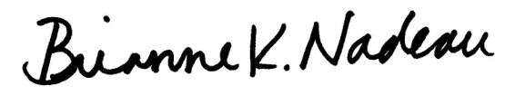
___________________________ ______________________________
Councilmember Janeese Lewis George Councilmember Brianne K. Nadeau

___________________________ ______________________________
Councilmember Robert C. White, Jr. Councilmember Christina Henderson
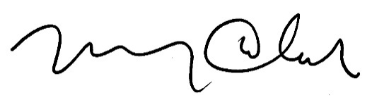

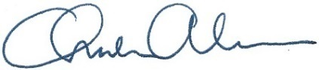
___________________________ ______________________________
Councilmember Mary M. Cheh Councilmember Charles Allen

A BILL

_________________________

IN THE COUNCIL OF THE DISTRICT OF COLUMBIA

_________________________

To amend the Construction Codes Approval and Amendments Act of 1986 to require that Diaper-changing Accommodations be available for use by all genders in newly constructed or substantially renovated District-owned and District-occupied buildings that include at least one toilet facility open to the public; and to require that Diaper-Changing Accommodations be available for use by all genders in newly constructed or substantially renovated business establishments and places of public accommodation that include at least one toilet facility open to the public.

BE IT ENACTED BY THE COUNCIL OF THE DISTRICT OF COLUMBIA, That this

act may be cited as the “Equal Access to Changing Tables Amendment Act of 2022”.

Sec. 2. The Construction Codes Approval and Amendments Act of 1986, effective March 21, 1987 (D.C. Law 6-216; D.C. Official Code § 6-1401 et seq.), is amended as follows:
(a) Section 2 (D.C. Official Code § 6-1401) is amended as follows:
(1) A new paragraph (1A) is added to read as follows:
“(1A) “Business establishment” means any entity, however organized, which furnishes goods or services to the general public. An otherwise qualifying establishment which has membership requirements is considered to furnish services to the general public if its membership requirements consist only of the payment of fees or consist of requirements under which a substantial portion of the residents of the District could qualify.”.
(2) A new paragraph (6A) is added to read as follows:
“(6A) “Diaper-changing accommodation” means a safe, sanitary, and convenient baby diaper-changing station, or similar amenity, including work surfaces, stations, decks, and tables, located in a toilet facility.”.
(5) A new paragraph (11A) is added to read as follows:
“(11A) “Substantially renovated” shall mean the construction, alteration, or repair of toilet facilities where the work requires a permit and the construction cost is $10,000 or more.”.
(b) A new section 10d is added to read as follows:
“Sec. 10d. Diaper-changing accommodations.
“(a) All newly constructed or substantially renovated District-owned, District instrumentality-owned, and District-occupied buildings that include at least one toilet facility that is open to the public shall provide on each floor level that includes a toilet facility available for use by the public:
“(1) At least one diaper-changing accommodation that is available for use by women and at least one that is available for use by men;
“(2) At least one diaper-changing accommodation that is available for use in a gender-neutral toilet facility; or
“(3) At least one diaper-changing accommodation in a private room, space, or area that is available for use by all genders.
“(b) All newly constructed or substantially renovated business establishments and places of public accommodation, as defined in section 102(24) of the Human Rights Act of 1977, effective December 13, 1977 (D.C. Law 2-38; D.C. Official Code § 2-1401.02(24)), that include at least one toilet facility that is open to the public shall provide on each floor level that includes a toilet facility available for use by the public:
“(1) At least one diaper-changing accommodation that is available for use by women and at least one that is available for use by men;
“(2) At least one diaper-changing accommodation that is available for use in a gender-neutral toilet facility; or
“(3) At least one diaper-changing accommodation in a private room, space, or area that is available for use by all genders.
“(c) Notwithstanding subsections (a) and (b) of this section, a diaper-changing accommodation shall not be required if:
“(1) The Director of the Department of Consumer and Regulatory Affairs, or his or her designee, in consultation with the Office of Disability Rights, determines that installation of a diaper-changing accommodation will not comply with District or federal laws relating to access to persons with disabilities;
“(2) The Director of the Department of Consumer and Regulatory Affairs, or his or her designee, determines that installation of a diaper-changing accommodation is infeasible due to spatial or structural limitations;
“(3) A business establishment holds a Class C/N or Class D/N nightclub license issued by the Alcoholic Beverage Regulation Administration; or
“(4) A business establishment lawfully, exclusively, and at all times serves patrons three years of age and above.
“(d) Nothing in this section shall be construed as requiring or authorizing:
“(1) A reduction in the number of toilet facilities that are required by the Construction Codes as defined in section 2(2) of the Construction Codes Approval and Amendments Act of 1986, effective March 21, 1987 (D.C. Law 6-216; D.C. Official Code § 6-1401(2)); or
“(2) A reduction in the number of toilet facilities accessible to persons with disabilities that are otherwise required under either the Construction Codes as defined in section 2(2) of the Construction Codes Approval and Amendments Act of 1986, effective March 21, 1987 (D.C. Law 6-216; D.C. Official Code § 6-1401(2)), or the federal Americans with Disabilities Act.
(e) The Mayor, in consultation with the Construction Codes Coordinating Board or its successor, shall propose regulations implementing this section no later than 180 days after adoption of this section, through amendment of section 2(2) of the Construction Codes Approval and Amendments Act of 1986, effective March 21, 1987 (D.C. Law 6-216; D.C. Official Code § 6-1401(2)), and such regulations shall be included in subsequent editions of the Construction Codes.”.
Sec. 3. Fiscal impact statement.
The Council adopts the fiscal impact statement in the committee report as the fiscal impact statement required by section 4a of the General Legislative Procedures Act of 1975, approved October 16, 2006 (120 Stat. 2038; D.C. Official Code § 1-301.47a).
Sec. 4. Effective date.
This act shall take effect following approval by the Mayor (or in the event of veto by the Mayor, action by the Council to override the veto), a 30-day period of congressional review as provided in section 602(c)(1) of the District of Columbia Home Rule Act, approved December 24, 1973 (87 Stat. 813; D.C. Official Code § 1-206.02(c)(1)), and publication in the District of Columbia Register.

